WEEK 11- AWS ACCOUNT CREATION

BY ANGELENA

22BD1A0585

1. Go the mail received and click on Get Started

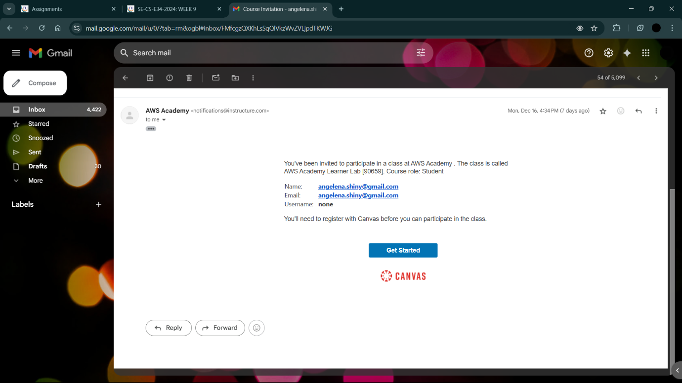

1. Click on Create My Account

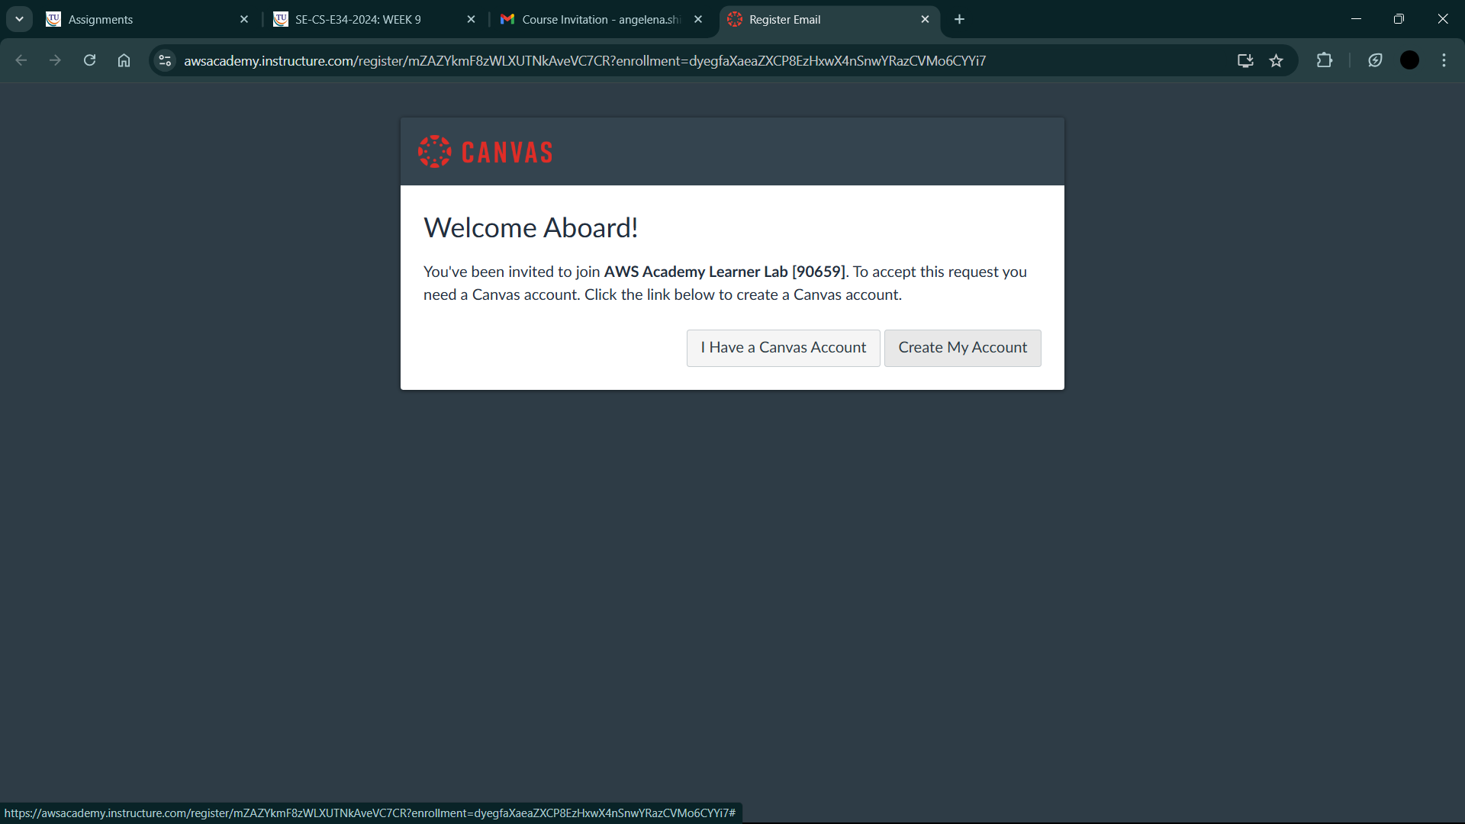

1. Give a password -> Give personal email ->Agree to conditions

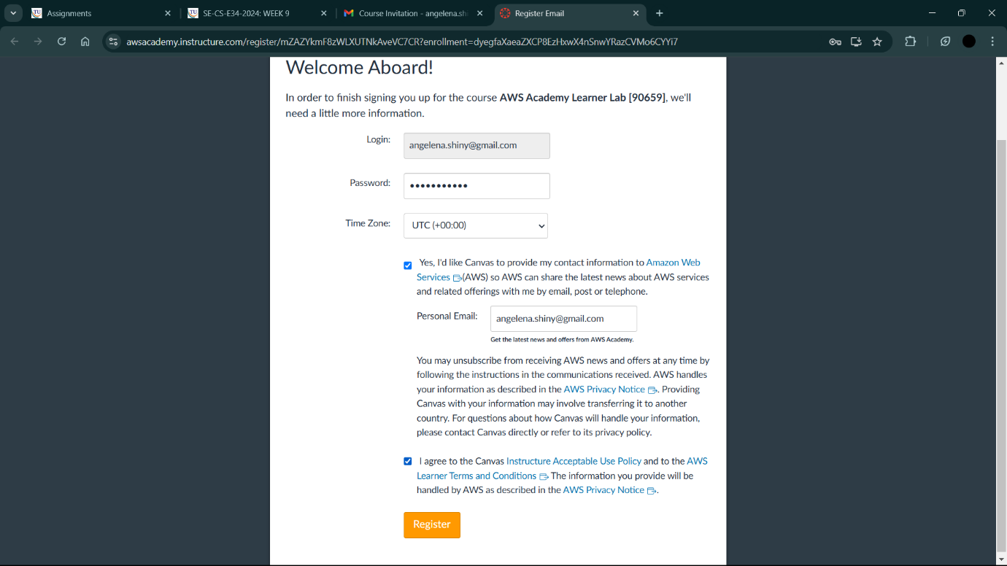

1. Click on Register

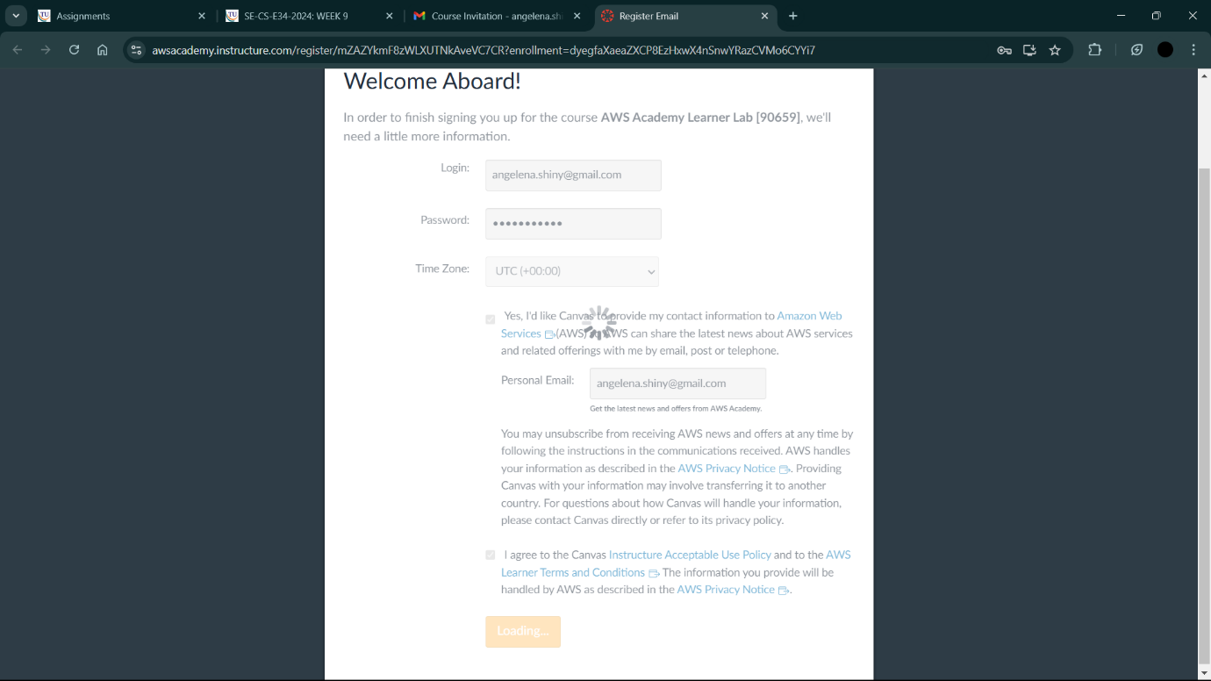

1. You will be directed to the aws dashboard

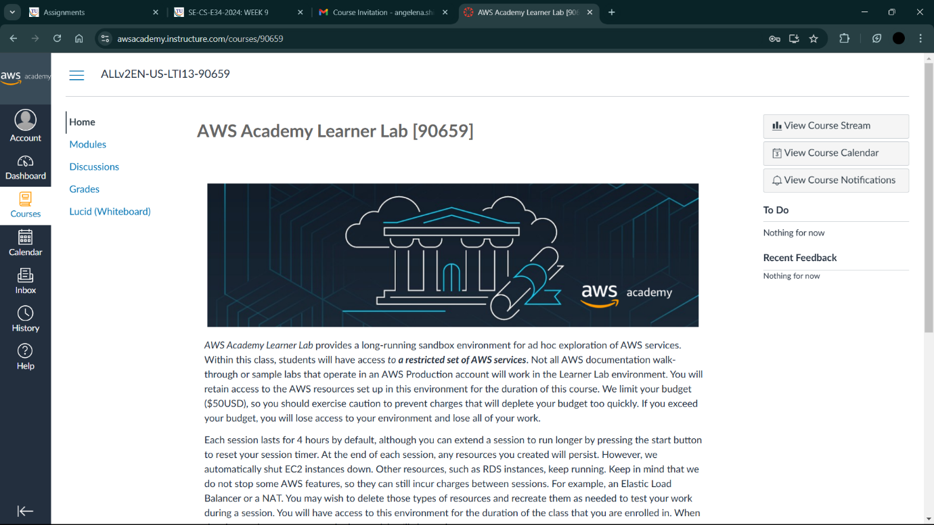

1. Go to Modules

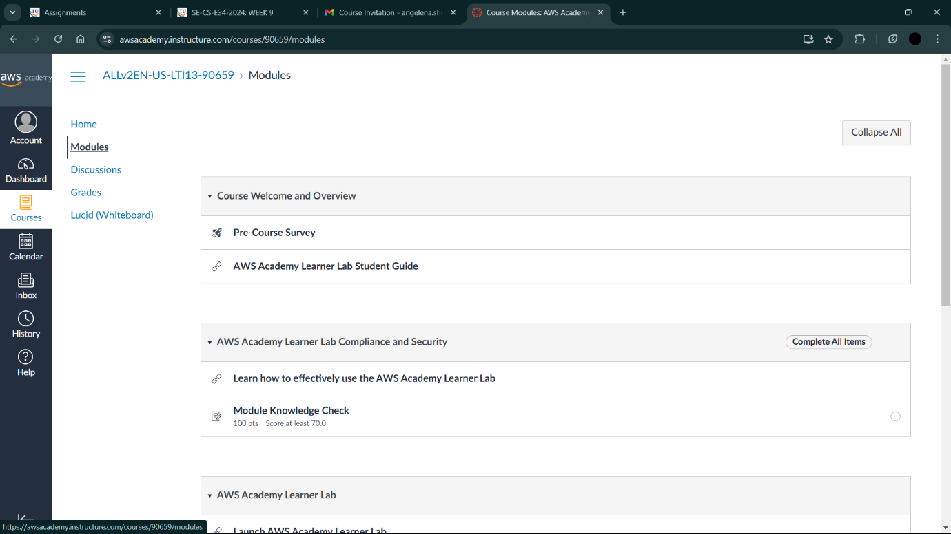

1. Scroll down and click on Launch AWS Academy Learner Lab

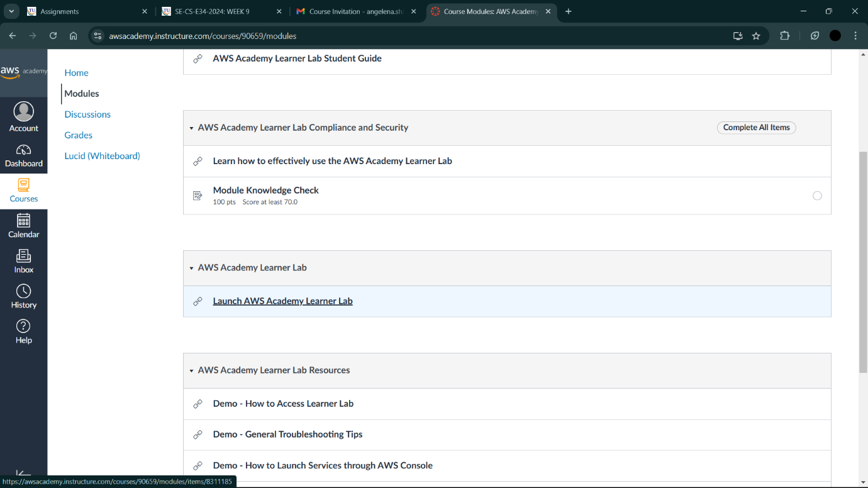

1. You will get terms and conditions

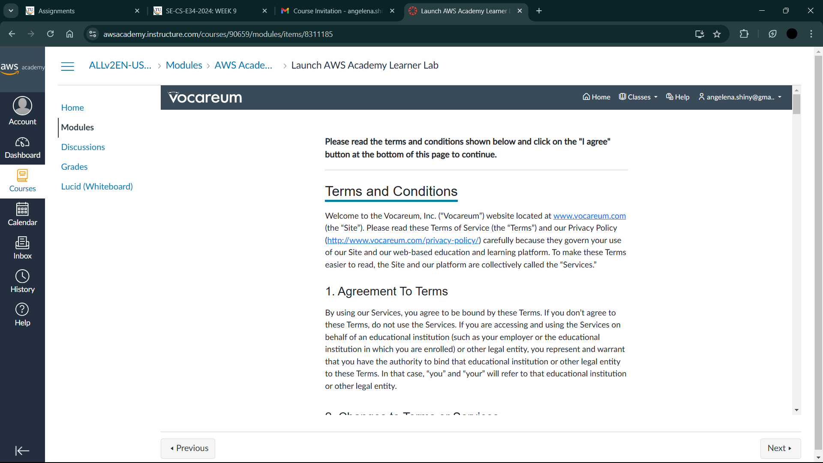

1. Click on I Agree

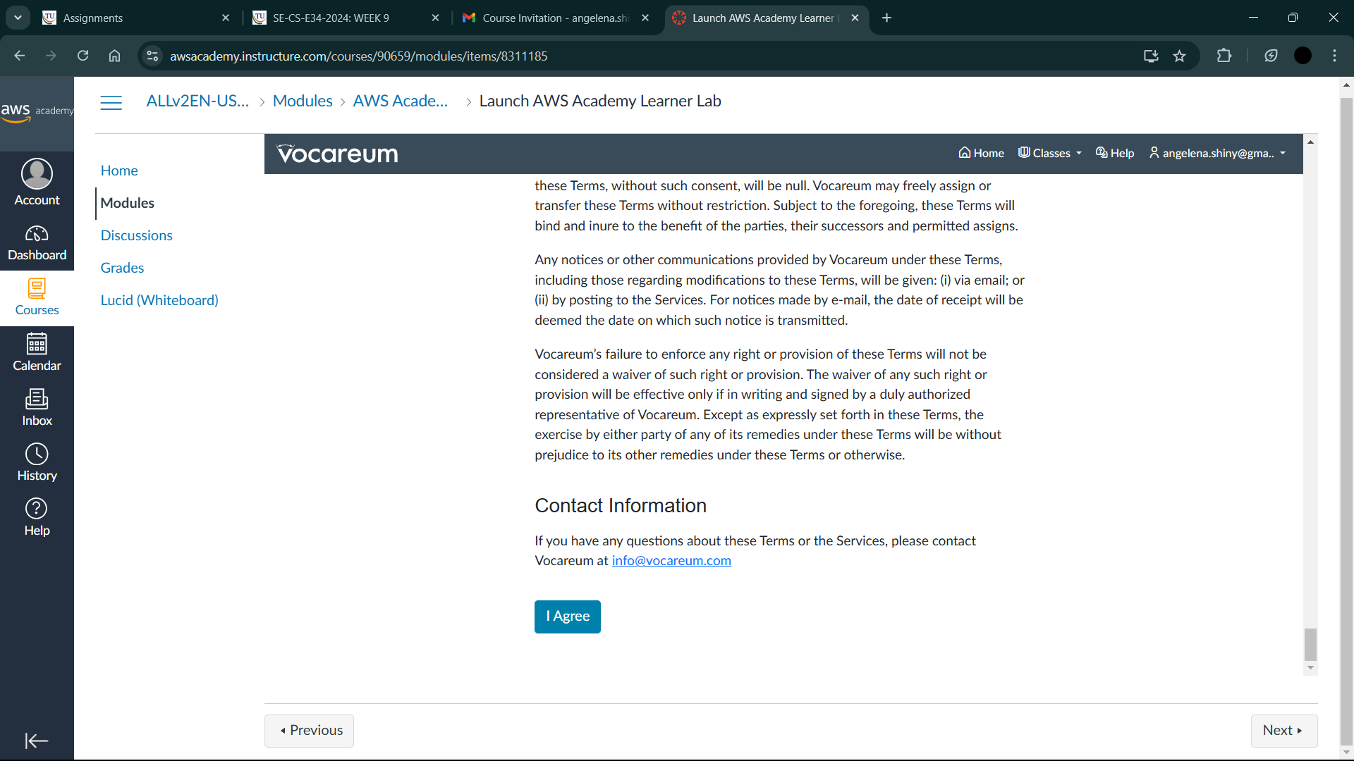

1. The loading starts

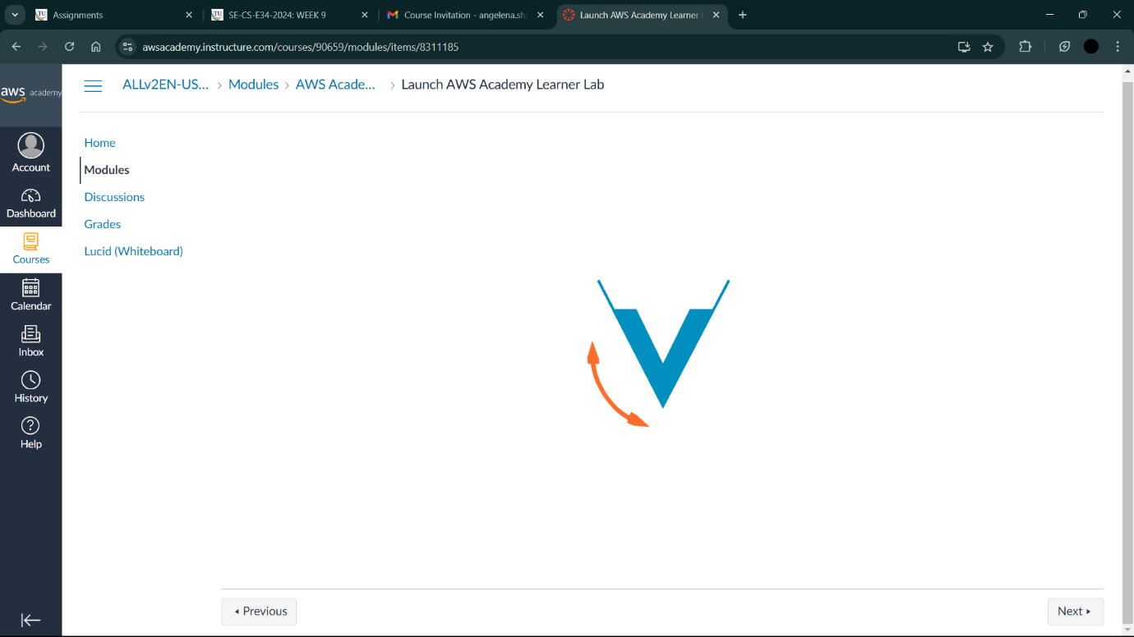

1. You will get this page

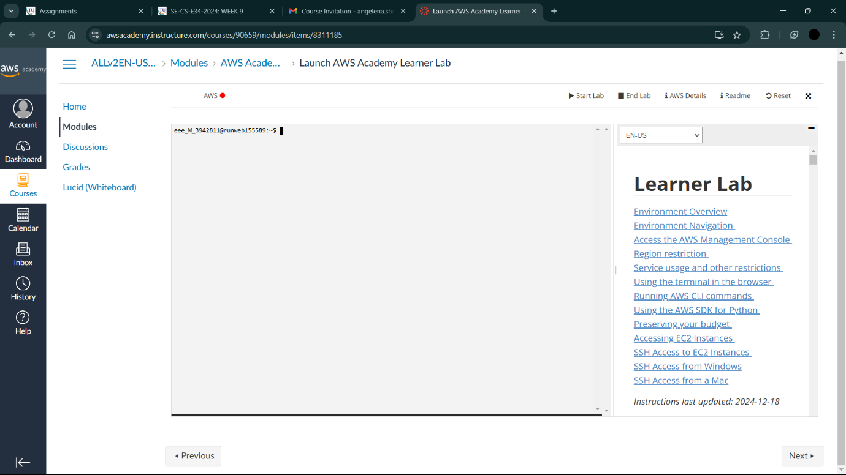

1. Click on Start Lab

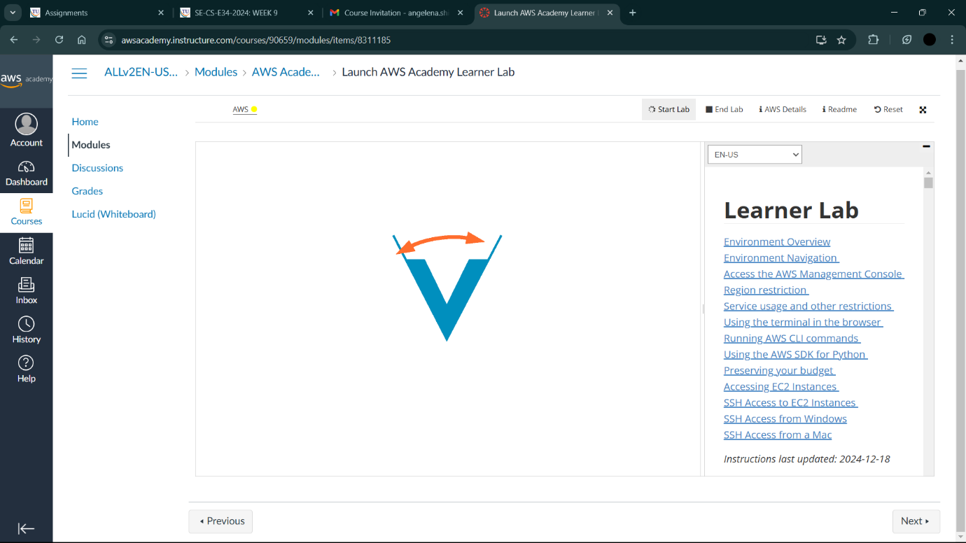

1. You will see the green colour dot once the lab starts

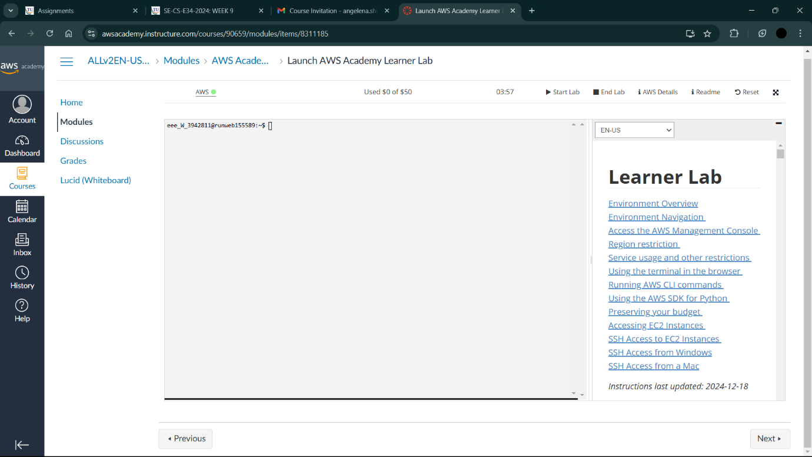

1. Click on That aws and you will reach this page

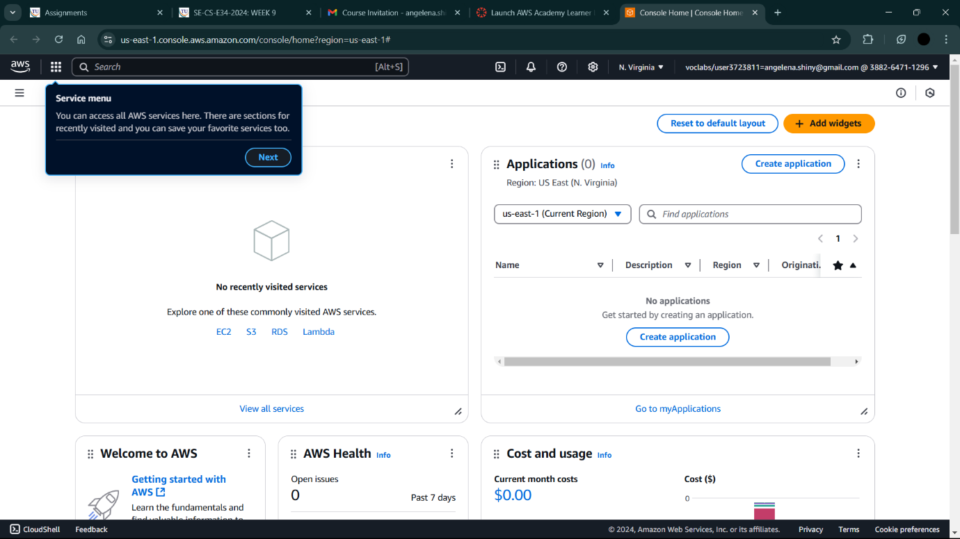

1. Click on EC2

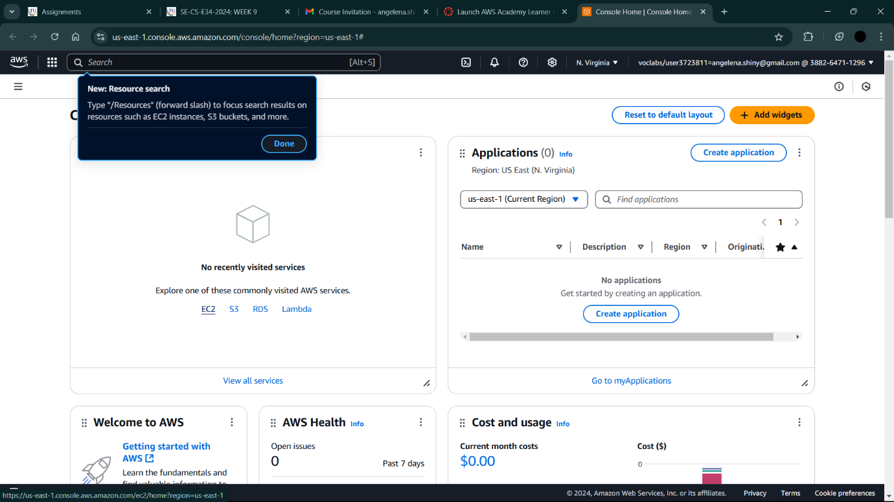

1. Here we can do our exercises

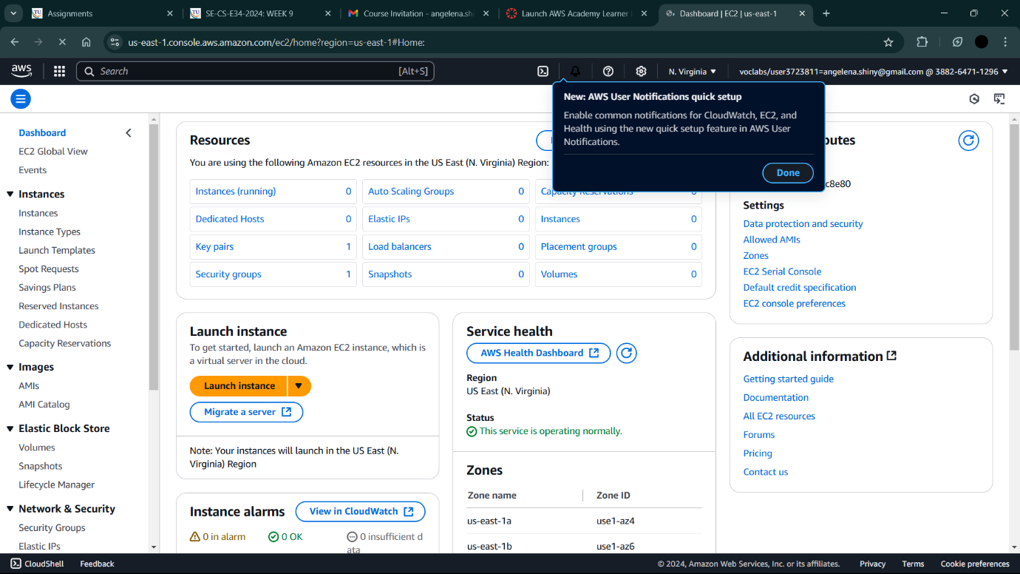

1. Once we are done with our exercises we should click on End Lab

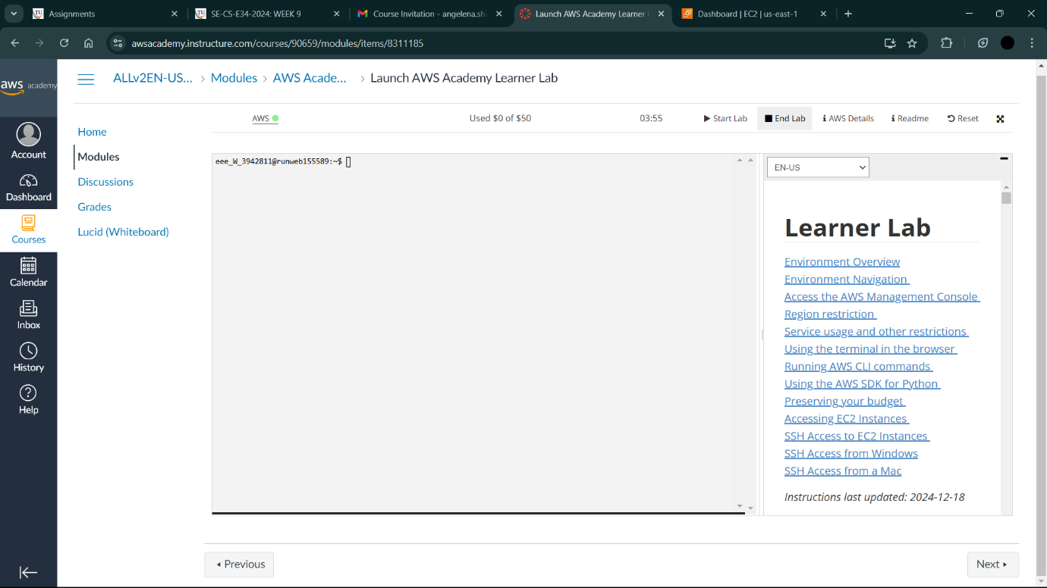

1. Click on Yes

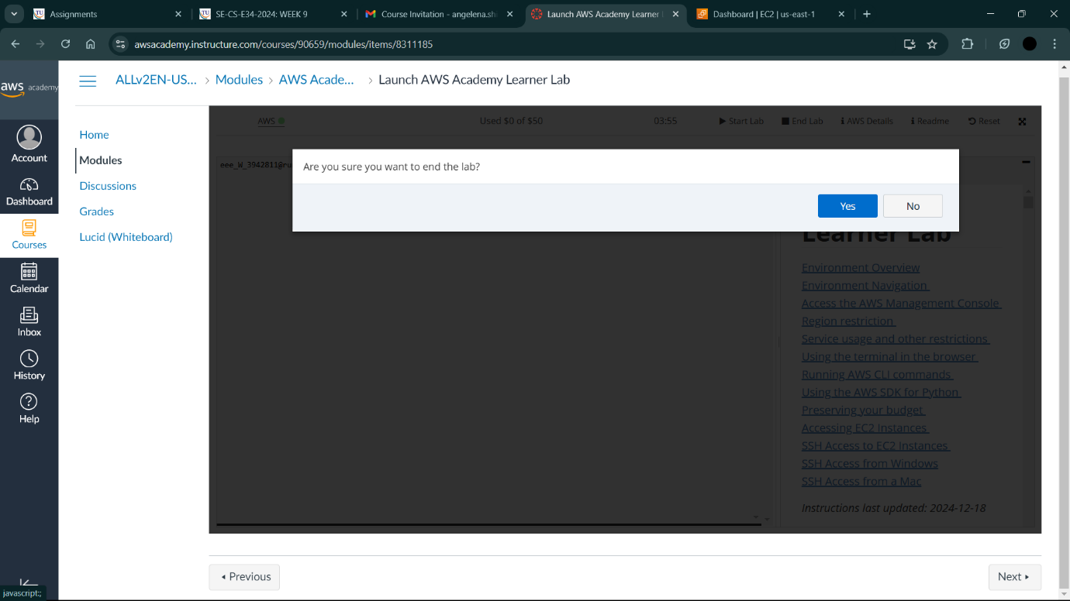

1. You can see the red dot which indicates that the lab has ended.

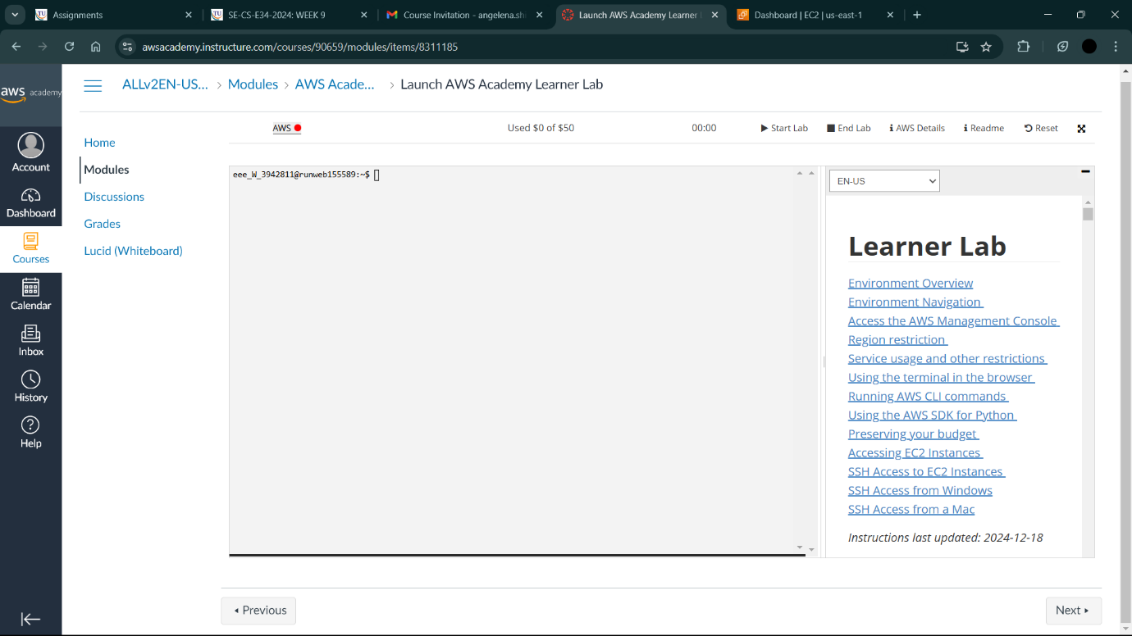

AND THAT’s IT!!!!